Name: _________________________________ Date: _________________ Class Hour: __________

Thematic Apperception Test

Directions: Please consider and respond to the following questions in regards to the image below.

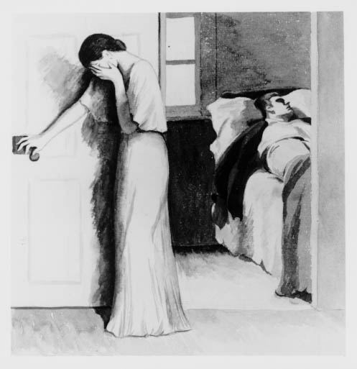

- What has led up to the event shown?
- What is happening at the moment?
- What are the characters feeling and thinking?
- What was the outcome?

Name: _________________________________ Date: _________________ Class Hour: __________

Thematic Apperception Test

Directions: Please consider and respond to the following questions in regards to the image below.

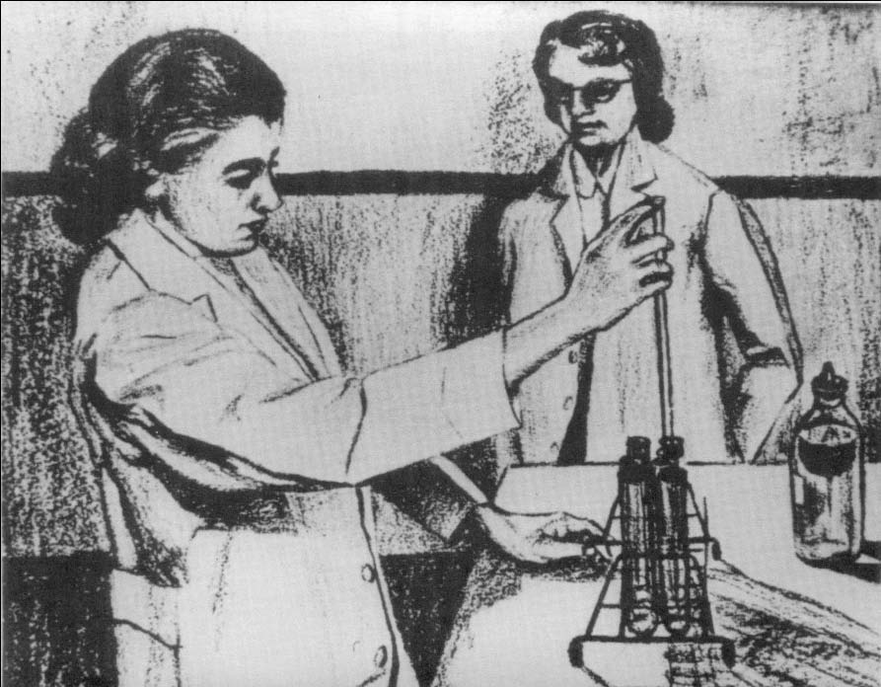

- What has led up to the event shown?
- What is happening at the moment?
- What are the characters feeling and thinking?
- What was the outcome?

Name: _________________________________ Date: _________________ Class Hour: __________

Thematic Apperception Test

Directions: Please consider and respond to the following questions in regards to the image below.

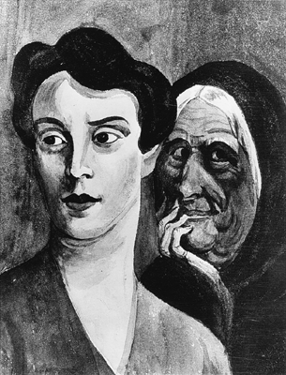

- What has led up to the event shown?
- What is happening at the moment?
- What are the characters feeling and thinking?
- What was the outcome?

Name: _________________________________ Date: _________________ Class Hour: __________

Thematic Apperception Test

Directions: Please consider and respond to the following questions in regards to the image below.

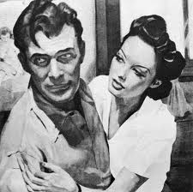

- What has led up to the event shown?
- What is happening at the moment?
- What are the characters feeling and thinking?
- What was the outcome?

Name: _________________________________ Date: _________________ Class Hour: __________

Thematic Apperception Test

Directions: Please consider and respond to the following questions in regards to the image below.

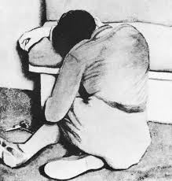

- What has led up to the event shown?
- What is happening at the moment?
- What are the characters feeling and thinking?
- What was the outcome?

