Name: _____________________________________ Date: ____________ Period: _____

Yann Martel
Life of Pi | Background

Directions: The best way to remember authors is to act as though they are people that you know in real life. Try to remember the basics, but also random facts about each author. In the long run, it is the random things that we retain. This is an autobiographical overview of Yann Martel.

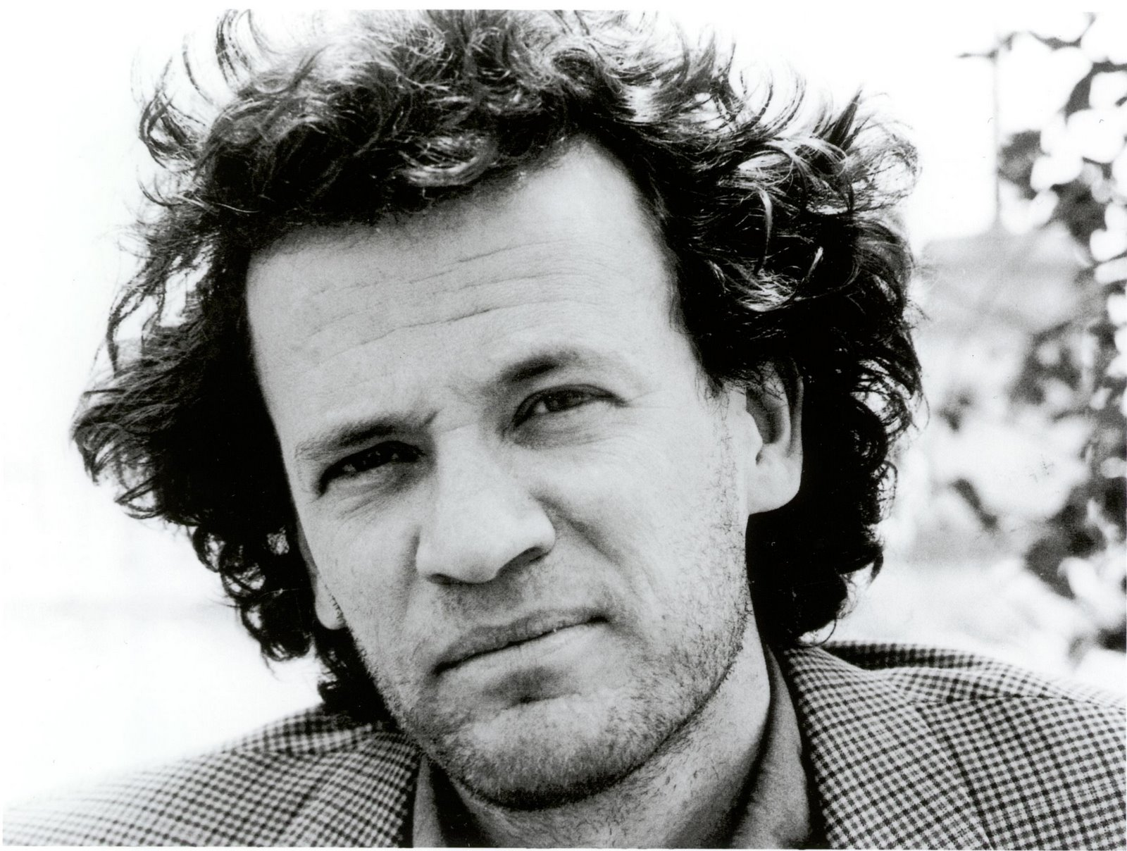
Once upon a time…
There were two French Canadians who fell in love and decided to have a child. They named their child, Yann Martel. He was destined for great things. Though he was French Canadian, he was born in Spain, where his mother was continuing her education. His mother was highly educated and his father was as well. They joined the Canadian service and traveled to many different places. Therefore, Yann moved many places throughout his childhood.

Yann attended high school and college in Ontario, where he pursued undergraduate and graduate studies in philosophy. Philosophy is the study of the schools of thought that influence science and art. After school, he travelled extensively as a young adult. He lived in Iran, Turkey, and India. He spent two years studying religions of the world. In these two years, he devoted himself to reading as many religious doctrines and castaway narratives as possible. In the meantime, he took on many odd jobs. He was a tree planter, dishwasher, security guard, and parking lot attendant. At the age of twenty-seven, he decided that he was ready to be a writer. And so, he wrote. He began writing in 1993.

Many of his works are not recognized today, as they should be. However, his book Life of Pi is often taught in classrooms across the United States. He published Life of Pi in September of 2001. This text gained national attention and won all of these cool honors and awards. He now lives in Saskatoon, Canada. His writing explores the complexities of human emotion, perspective, and experience.

