Name: _____________________________________ Date: ____________ Period: _____

Harper Lee
To Kill a Mockingbird | Background

Directions: The best way to remember authors is to act as though they are people that you know in real life. Try to remember the basics, but also random facts about each author. In the long run, it is the random things that we retain. This is an autobiographical overview of Harper Lee.

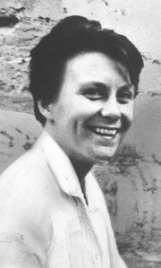
And so the story goes that…
In the spring of 1926, Nelle Harper Lee was born, the youngest of five children in Monroeville, Alabama. Her name was her grandmother’s name backwards. Her nom de plume is Harper Lee. She grew up a tomboy, spending the majority of her childhood in Alabama.

Lee attended high school at Monroe County Public High School, where she developed her love for English literature. She attended a private, all-girl college for a year, before transferring to the University of Alabama. She wrote for the newspaper. However, she never finished her degree.

In 1949, she moved to New York City. She worked as an airline reservation assistant for a little while. It wasn’t until 1956 (7 years later) that she found an agent for her true passion- writing. He gave her one-year off from working to write a novel… So, she wrote the framework of To Kill a Mockingbird during that time frame. It would take another few years of revision before the book was published in 1960. It was an immediate hit as it entered society during the Civil Rights Movement. It won the Pulitzer Prize and secured itself as a classic in American Literature.

Lee did not like fame. She preferred to live her life independently from the success of her novel. She attempted to write again, but could not seem to meet the same satisfaction as she had with TKAM. It was not until this year that her second book, Go Set a Watchman was published. TKAM was based largely on the events and individuals that Lee knew in her childhood. However, it is the universal questions of morality, equity, justice, and racial controversy that make her text one of the most studied texts in classrooms across the United States.

Notes:

