Excerpts from Interview with Yann Martel

Components of the Book:
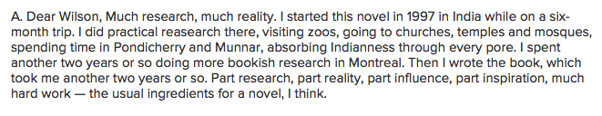
The Name Richard Parker:
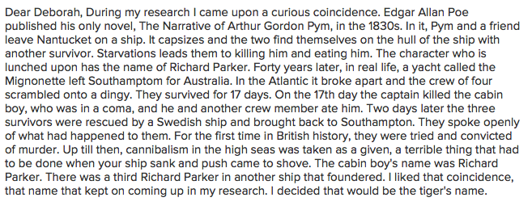
The Creating of the Story:
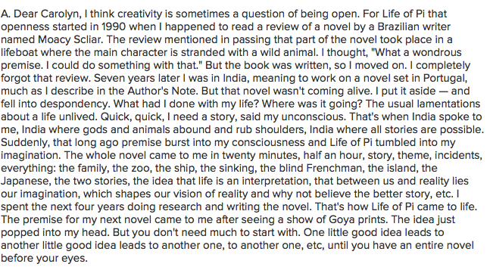

The Magic of Magical Realism: 